**Logo%20Main%20200**

**Boston University**

**Electrical & Computer Engineering**

**EC463 Senior Design Project**

**First Prototype Testing Plan**

**Mars Rover: Autonomous Navigation**

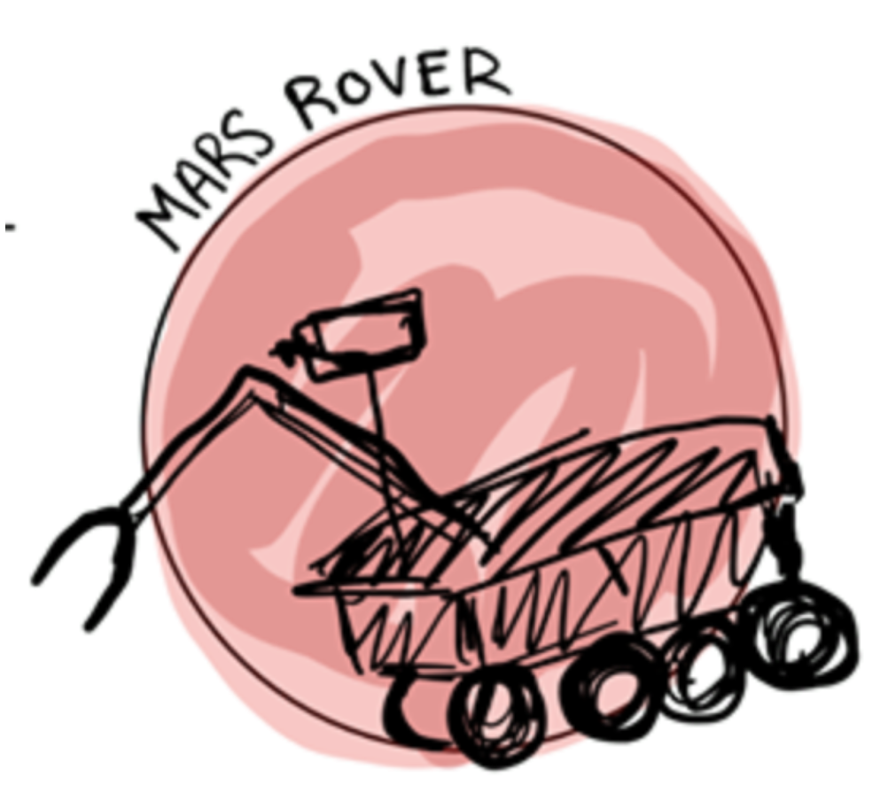

by

Team #28

Rover Boi

Team Members

Daniel Crawley crawley@bu.edu

Brian He brianhe@bu.edu

Tommy Lam tlam11@bu.edu

SeungYeun Lee sylee538@bu.edu

Linden Vo [lindenvo@bu.edu](mailto:lindenvo@bu.edu)

**Required Materials**

Hardware:

* 1/8th 4WD Electric Power R/C Rock Crawler
* ESP32 Micro Controller
* Battery(7.2V,2000mAh) 51C00-03200
* Intel RealSense D415 Depth Camera
* TFMini - Micro LiDAR Module
* LIDAR lite v3
* Servo(9KG)(Waterproof) 51C00-SP9002
* Electronic Speed Controller (Waterproof) 98120
* Motor (RC540) W/ Gear (12T) 03012

Software:

* Windows 10 Operating Systems
* Visual Studio Community 2019
* Espressif
* ESP32 Script
  + Calibrate the motors of the rover
  + Drive motors and avoid obstacles
* Intel RealSense Librealsense Library
  + Realsense Viewer

**Setup**

Our equipment set up is the crawler itself with all necessary sensors and controllers attached onto the top of the Rover. We have the MaxSonar Ultrasonic Range Finder mounted on the front of the vehicle. It will detect when our Rover reaches a wall and will stop accordingly. We also have two TFMini Micro Lidars mounted on the left side of our Rover. It will serve as the basis of the steering logic for our Rover, for now. Depending on the readings from the two MicroLidars, our servos will either turn left, right, or go straight and will avoid collision. We also have a separate Intel RealSense Camera D415 Depth Camera with many built in functionalities.

**Pre-testing Setup Procedure:**

ESP32 (if Espressif is not installed on windows)

* Follow the instruction as shown in this website (<https://docs.espressif.com/projects/esp-idf/en/latest/get-started/index.html>)

ESP32 (Espressif installed on windows)

1. Make sure all ESP32 GPIO are connected correctly.

Make sure Rover is wired correctly as per the diagram:



Key:

1. Servo 51C00-SP9002
2. LIDAR lite v3 module
3. TFMini - Micro LiDAR Module - “Sensor 1”
4. ESP32
5. 7-segment display
6. TFMini - Micro LiDAR Module - “Sensor 2”
7. Optical Encoder
8. Front Stepper Motor
9. ESC
10. Rear Stepper Motor

ESP32:

*cd into* folder ec463 and run *idf.py -p [PORT] flash monitor*

Intel RealSense Camera:

From terminal with librealsense installed in installation directory, run ./realsenseviewer

**Hardware Pinout**

|  |  |
| --- | --- |
| **ESP32 Pin #** | **Usage/Description** |
| A5 (GPIO #4) | Optical encoder (PCNT pulse input) |
| 14 (GPIO #14) | UART_TX for left side front micro lidar |
| SCK (GPIO #5) | UART_RX for left side front micro lidar |
| 27 (GPIO# 27) | UART_TX for left side back micro lidar |
| 15 (GPIO#15) | UART_RX for left side back micro lidar |
| SCL (GPIO #22) | i2c clk for LiteLidar V3 |
| SDA (GPIO #23) | I2C data for LiteLidar V3 |
| SCL (GPIO #22) | i2c clk for alphanumeric display |
| SDA (GPIO #23) | I2C data for alphanumeric display |
| MOSI (GPIO #18) | esc (PWM0A) |

**Testing Procedure**

1. Place the Rover onto the ground at least 1 feet away from and parallel to the wall.
2. Check to make sure the sensors are working as expected by covering individual sensors.
   1. Covering Sensor 1 should turn the front wheels right.
   2. Covering Sensor 2 should turn the front wheels left.
   3. Covering front sensor should stop the vehicle.
   4. Can use serial port and terminal to debug if necessary to determine if measurements are accurate
3. Turn on the ESC on the right side of the Rover.
4. Power ESP32 with external 5V power bank.
5. After three seconds, Rover will begin moving.
6. Monitor Rover and make sure it meets all measurable criteria.

**Overview of Steering Logic**



**Measurable Criteria**

Criteria for successful running and output are like such:

1. The Rover should successfully move parallel to the wall.
2. Rover should be able to move at 0.1 m/s - 0.5 m/s.
3. Rover should be able to accurately detect the distance of objects in front of it and stop within 20cm of the object.
4. Rover should be able to steer and avoid collision when detected. It should change direction when an object is detected on the side or when it is in a corner.

**Score Sheet**

|  |  |
| --- | --- |
| **Objectives** | **Complete? (Y/N)** |
| Travel 5m |  |
| Travel parallel to the wall |  |
| Travel at a constant speed |  |
| Stop before hitting a wall |  |
| Steer to avoid collision |  |
| RealSense Camera able to detect and return distance |  |
| RealSense Camera able to detect People |  |